Backyard Mission
.…repairing homes, restoring hope….

Mission Statement:

1. Get people warm and dry by providing free home repairs, using volunteer labor and buying materials with donated money. Demonstrating the love of Christ!

2. Give Christians/Service groups the opportunity to put their belief into action, by loving and serving their neighbors.

3. Help other churches start a Backyard Mission program. ________________________________________________________

HAPPY BIRTHDAY
BACKYARD MISSION

32 years ago this week Backyard Mission roofed it’s first house. I was running the ministry out of my garage, and drove a 1980 Jeep for a “work truck”.

I had no idea what I was doing or where the Lord would take things. It has been a great adventure!

All glory to Him!!

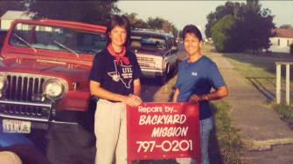

We appreciate and depend on your generous donations to continue this ministry. Consider giving a gift to Backyard Mission this fall.

--------------------------------------------
LAURIE FOSTER, Founder/Director
8205 Quincy Ave (806) 300-0184
Lubbock, TX 79424 (land line)
lfoster@backyardmission.org /www.backyardmission.org
September 2024

Projects to date – 1745

We just completed one of our most challenging projects in 32 years. I honestly was not sure we should attempt the repairs, but I heard the Lord say………Trust Me, Trust your team.
We are blessed with one of the most skilled volunteer teams we have ever had…aka…The Dream Team. They jumped in and did an amazing job for Ms. Wanna.
We were also blessed by Robbie Sanders with Schrader Roofing Co. They donated re-roofing the addition for us, which was crucial for the integrity of our other repairs. They also provided a dump trailer so we were able to remove years of debris from the yard.
Ms. Wanna is known for giving a shout out to the Lord throughout the day, and the roofing crew gave her the name “Hermana Hallelujah”……….perfect!

